How to Choose a Medical Alert System
Concerned about falling or needing help with a health problem when you’re alone?
Medical alert systems—where the press of a wearable call button puts you in touch with a dispatcher who can summon emergency help or contact a friend or family member—may offer some reassurance.
“Anyone who is at risk of falling or having a medical emergency” may benefit from such a device, says Leah Bellman, M.S., an occupational therapist and a healthcare process improvement analyst with Commonwealth Care Alliance in Boston.
If you’re considering using such a system, which should you choose? The wide variety of features, service options, and fees can make it challenging to figure out what’s best for you.
Best Medical Alert Systems
Also, you might wonder whether you can simply rely on the technology you already have, such as a smartphone. Probably not, experts say.
That’s because it’s unlikely that you have your smartphone with you all the time, says Mindy Renfro, PhD, an associate professor in the school of physical therapy at Touro University Nevada in Henderson. It’s easy to get up from a chair and leave it there. “If you don’t have an emergency response system on your body that is going to stay on your body, you’re at risk,” she says.

SOURCE: https://www.consumerreports.org/medical-alert-systems/how-to-choose-a-medical-alert-system-a1228040748/
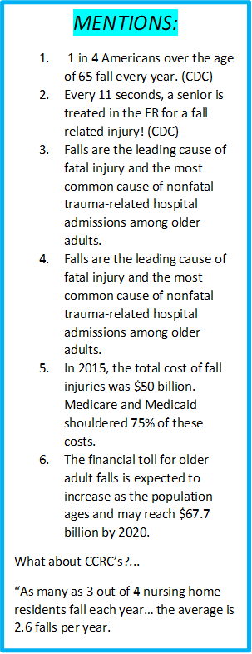

3 Key Questions to Answer First

1. Do You Want a Home-Based or Mobile System?
Originally, medical alert systems were designed to work inside your home with your landline telephone.
And you can still go that route. Many companies now also offer the option of home-based systems that work over a cellular network for those who might not have a landline.
With these systems, pressing the wearable call button allows you to speak to a dispatcher through a base unit located in your home.
But many companies offer mobile options, too. You can use these systems at home, but they’ll also allow you to call for help while you’re out and about.
These operate over cellular networks and incorporate GPS technology. This way, if you get lost or press the call button for help but are unable to talk, the monitoring service can find you.
2. Should Your System Be Monitored or Not?
The systems we’ve provided information on below are all monitored, meaning that the call button connects you with someone at a 24/7 dispatching center.
But you have the option to choose a system that isn’t monitored. With these, when you press the call button, the device automatically dials a friend or family member on your programmed emergency call list.
These products can often be set up to call multiple people and to contact emergency services if you don’t get an answer from someone on your list.
A key difference between the two is price. Monitored systems carry a monthly fee in addition to the purchase price for the device.
3. Should You Add a Fall-Detection Feature?
Some companies offer the option of automatic fall detection for an additional monthly fee. Manufacturers say these devices sense falls when they occur and automatically contact the dispatch center, just as they would if you had pressed the call button.
That sounds great, but it might not work perfectly every time, says Neil Alexander, MD, a professor of geriatric and palliative medicine at the University of Michigan and director of the VA Ann Arbor Healthcare System Geriatric Research, Education, and Clinical Center.

SOURCE: https://www.consumerreports.org/medical-alert-systems/how-to-choose-a-medical-alert-system-a1228040748/

Apple Watch 7 Vs Fitbit Sense
The comparison between Apple watch 7 and the Fitbit Sense offers insights into key differences between the Apple’s latest model and the Fitbit’s best smart watch model. The cost of Apple watch 7 is nearly double of the costs of the Fitbit Sense. What does the Apple watch 7 offers in terms of its incremental cost over the Fitbit Sense model?
Fall detection – Apple watch 7 Vs Fitbit Sense
There is no match when it comes to Apple watch’s fall detection feature. Even the more expensive Garmin watches cannot match Apple watch 7’s fall detection feature and its reliability. On a similar note, a Fitbit Sense does not offer the fall detection feature as of writing this piece in December 2021.
If fall detection is a must-have feature for you to have, you would be better off with an Apple watch series. An Apple watch 7 continues the legacy of a highly reliable fall detection feature on the watch.

SOURCE: https://www.techepages.com/apple-watch-7-vs-fitbit-sense/#Fall_detection_-_Apple_watch_7_Vs_Fitbit_Sense

Are wearable devices effective for preventing and detecting falls: an umbrella review (a review of systematic reviews)
Falls are a common and serious health issue facing the global population, causing an estimated 646,000 deaths per year globally. Wearable devices typically combine accelerometers, gyroscopes and even barometers; using the data collected and inputting this into an algorithm that decides whether a fall has occurred. The purpose of this umbrella review was to provide a comprehensive overview of the systematic reviews on the effectiveness of wearable electronic devices for falls detection in adults.
Conclusions
This review demonstrated that wearable device technology offers a low-cost and accurate way to effectively detect falls and summon for help. There are significant differences in the effectiveness of these devices depending on the type of device and its placement. Further high-quality research is needed to confirm the accuracy of these devices in frail older people in real-world settings.

SOURCE: https://bmcpublichealth.biomedcentral.com/articles/10.1186/s12889-021-12169-7

