The Psoas Muscle – A Key to Good Balance
Christina's Blog
You may be unfamiliar with it, but it is one of the most essential muscles in our bodies – the psoas (so-az) muscle. The psoas drastically impacts our health and well-being, from our stability and balance as we walk, bend, and turn, to the way we feel emotionally.
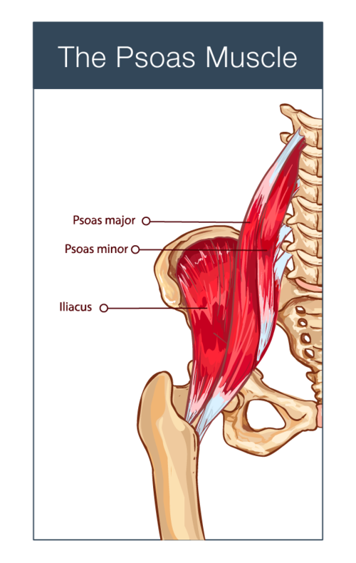
While the psoas muscle is commonly referred to in the singular, it is actually comprised of the psoas major, psoas minor, and the iliacus muscles, with one set of each on either side of the body. It connects to the spine, lying deep within our abdominal cavity and with its connective tissue it extends from the diaphragm all the way down through the pelvis to the pelvic floor, joining with the upper part of each leg.
The psoas is the only muscle that links the trunk of the body to the legs. This is why it is important for stability – its anatomical function is to connect the upper body to the lower body, the outside to the inside, the legs to the spine, and the front to the back. It stabilizes the hip/leg connection and is active when we bend our legs to walk, get up from lying down, rotate our body from side to side, bend down, sit upright, and stand erect. Any time we are moving, our psoas is involved. We want it to be relaxed and responsive in order to keep us balanced and strong, able to catch our balance when an impending fall might otherwise take us down.
In addition to the structural functions of the psoas muscle, it is linked to our central nervous system through a neurological connection with our primitive, reptilian brain. Because of this, the psoas functions instinctively whenever we feel threatened – automatically contracting as a means of defense and protection. It is the primary muscle involved when the sympathetic nervous system (our fight or flight mechanism) is activated. Trauma, sustained stress, or even everyday tensions will tighten and shorten the psoas, storing tension deep within us. This can lead to tightness all over the body, chronic pain, poor balance, and underlying anxiety or hyper-reactivity. It is one of the principal players in psychosomatic experiences and the reactive stress response. It is speculated that the psoas muscle underlies post-traumatic stress disorder (PTSD) and may, with careful therapeutic methods, contribute to healing. We are finding that this muscle is essential for emotional well-being, physical balance, whole-body coordination, and stability on many levels.
RESTORING OUR PSOAS MUSCLE TO A RELAXED, SUPPLE STATE IS CRUCIAL NOT ONLY FOR PHYSICAL HEALTH AND BALANCE BUT ALSO FOR MENTAL AND EMOTIONAL WELL-BEING.
There are simple movements drawn from Yoga, Brain Gym®, Tai Chi, QiGong, and physical therapy that have a profound effect on the psoas muscle, releasing tension, strain, and stored emotions. I incorporate many psoas release techniques into my classes, Stand Tall – Don’t Fall and Brain Power for Brain Injuries, to improve posture, balance, emotional equilibrium, and to restore optimal brain/body function.
Releasing the psoas helps to dismantle a multitude of muscular and skeletal compensations, unravel entrenched emotional patterns, and restore optimal neural functioning to support new energy, good balance, and a strong brain/body connection.
As we slowly release stored tension by lengthening and softening the psoas muscle, we will begin to feel an internal opening and an inner awareness. When we stand and then walk, we have an increased sense of uprightness, an awareness of our hips and core being somewhat “solid” and yet fluid, and an ease of movement that is surprising. Emotionally we feel refreshed and relaxed, and mentally much clearer. By freeing the psoas to move fluidly, we can experience a deep sense of calm, flexibility, emotional equilibrium, and physical stability.

TRY IT FOR YOURSELF!
Release stored tension through these simple, gentle movements combined with breathing. Find a quiet place with a firm chair and a mat so you can you begin to release and lengthen your psoas muscle with the following easy exercises:
1) Knee to chest. Sit on a firm chair and bring one knee to your chest by clasping your hands just below your knee and drawing it toward you. Breathe deeply into your belly and exhale, several times. Repeat with the other leg. You can also do this lying on your back.
2) Leg extension. Lie on your back on a firm bed or a mat on the floor. Bend both knees so your feet are flat on the floor. Roll your pelvis so that your spine is fully in contact with the floor (or as close as is comfortable for you). Then, very slowly, extend your right leg until it is resting on the floor. If your back has arched up off the floor, gently rotate your hips until your spine is flat against the floor. Hold for 1 minute. Repeat with your left leg.
If the full movement is difficult or causes strain, place a firm pillow under the extended leg until your muscle learns to relax. The psoas will eventually lengthen, allowing you to fully extend your leg.

What is Psoas Syndrome?

Psoas Syndrome
A very rare condition, psoas syndrome happens when the psoas muscle (a long muscle in the back) is injured. This condition causes back pain. Anyone can get psoas syndrome, but athletes are at a higher risk. It is typically treated with physical therapy.

OVERVIEW
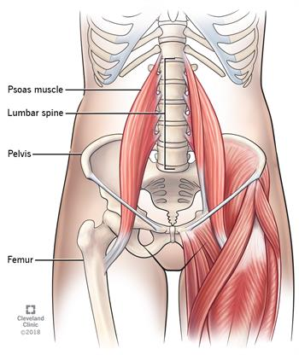

What is psoas syndrome?
Psoas syndrome is an uncommon, and often misdiagnosed, condition that can appear as refractory lower back pain (pain that stays even after treatment) accompanied by other symptoms. The condition occurs when the psoas muscle—the long muscle (up to 16 inches) in your back—is injured. The psoas muscle is located in the lower lumbar region of the spine and extends through the pelvis to the femur. This muscle works by flexing the hip joint and lifting the upper leg towards the body. A common example of the movement created from this muscle is walking.
Psoas syndrome is a very rare condition. Other conditions—disc herniation, arthritis, facet or sacroiliac pain—are much more common. When those conditions are treated, often with physical therapy, the psoas muscle is also stretched and strengthened. This can help treat psoas syndrome without it ever being diagnosed.

Who gets psoas syndrome?
Anyone can get psoas syndrome, but athletes, runners, and those engaged in plyometric jumping exercises (short-term, high-energy exercises like jumping rope) are at higher risk for the condition, due to the nature of their activities.

SYMPTOMS AND CAUSES

What causes psoas syndrome?
Psoas syndrome may have no identifiable cause. Care should be taken in people who are immune-compromised (due to transplant, cancer, or infectious causes) to ensure that there is no infectious cause or associated myositis (weakness) in the psoas muscle that presents in a related fashion.

What are the symptoms of psoas syndrome?
Psoas syndrome can cause a variety of symptoms, including:
- Lower back pain, the most common symptom, although this can be symptomatic of many conditions
- Pain in the lumbosacral region (the border between the lower part of the spine and the buttocks that can radiate up to lumbar vertebrae or down to the sacrum) when sitting or particularly when changing positions arising for sitting to standing
- Difficulty/pain when trying to stand in a fully upright posture
- Pain in the buttocks
- Radiation of pain down the leg
- Groin pain
- Pelvic pain
- Limping or shuffling stride when you walk
Many of these symptoms can mimic other, more serious conditions. Hip arthritis, kidney stones (ureteral calculi), hernias, femoral bursitis, prostatitis, salpingitis, colon cancer and colon diverticulitis can also cause severe back pain. It is important to consult your doctor if you have any of the above symptoms.

DIAGNOSIS AND TESTS

How is psoas syndrome diagnosed?
Psoas syndrome may be hard to diagnose since many of the symptoms are similar to several, more common conditions. If your doctor thinks you may have psoas syndrome, he or she will want to rule out other more serious causes.
Your doctor will usually be able to diagnose psoas syndrome with a combination of a physical examination of your spine, hip and leg, confirmed with advance radiological imaging.

MANAGEMENT AND TREATMENT

How is psoas syndrome treated?
Psoas syndrome is best treated with physical exercises. These are often demonstrated by a doctor or physical therapist in the outpatient office and done at home.
These exercises will include active and passive spine, hip joints, and psoas muscles manipulation and stretching. Exercises at home include stretching and lower-impact dynamic exercises “closed chain” designed to stretch and strengthen the psoas muscle and allow the body to repair the injury. It is very important that these be done only with guidance of your doctor so that you do not further injure your psoas or other muscles. Additional treatments may include osteopathic manipulative treatment, ultrasound, and rarely, injections to muscle or associated tendon structures.

OUTLOOK / PROGNOSIS

What is the prognosis for psoas syndrome?
With proper treatment and exercises, people suffering from psoas syndrome should be able to regain a full range of motion and resume a very high level of physical function.
https://my.clevelandclinic.org/health/diseases/15721-psoas-syndrome

ADDITIONAL SOURCES
NCBI, The National Center for Biotechnology Information - https://www.ncbi.nlm.nih.gov/Anatomy, “Bony Pelvis and Lower Limb, Psoas Major” Marco A. Siccardi; Muhammad Ali Tariq; Cristina Valle.
Brain Gym®, Teachers Edition, Paul E. Dennison and Gail E. Dennison
“The Emotional Core: aka the Psoas”: https://www.pilatesnosara.com/
Liz Koch: https://coreawareness.com/about/psoas/
The Trauma Conscious Yoga Institute: https://traumaconsciousyoga.com/psoas﻿

Strengthening and progression exercises
- 3-4 times per week (every other day)
- Start with 1 set of 10-15 repetitions
- Progress gradually to 3 sets of 10-15 repetitions, take a 1-2 minute break between sets
- Think slow and controlled movements, no need to hold the position
- Move on to an exercise labeled “progression” when you can easily complete 3 sets of 10-15 repetitions
- Repeat exercises on your other leg
Tips:
- It is normal for muscles to feel sore or even shaky when starting a new exercise
- Joint pain is not normal. Pain, unlike soreness, is an indicator that you may be overdoing it with your exercises. Rest for 1-2 days and then start exercising again slowly
- Gradually increase your activity level
- Walking DOES NOT take the place of your exercises
- Continue with these strengthening exercises for at least the first year after your surgery
7. Bridge progression
8. Clam shell
9. Hip flexor strengthening
10. Standing hip abduction progression
11. Squat progression
12. Crab walk
13. Standing abduction against wall
14. Marching in standing
Stretches
- Warm up for 5-10 minutes before stretching (e.g walking, warm shower)
- Hold stretches 45 seconds (or 5 slow deep breaths), repeat 3 times
- Can be done everyday or several times a day if your muscles are tight
- Repeat with the other leg

Exercise instructions
15. Hip bending stretch
16. Hip flexor stretch
17. Seated hamstring stretch
18. Adductor stretch
19. Side stretch
SOURCE: https://sunnybrook.ca/content/?page=musculoskeletal-hip-replacement-progression

