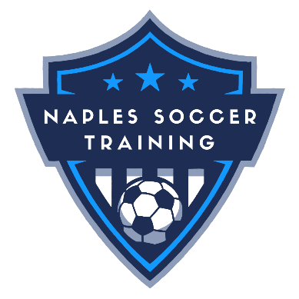
NST Weight Training Program
- Six week program
- 90 min. sessions (45 minutes in the weight room/45 minute SAQ session)
- 12 sessions total (2 per week)
- Groups of 4-10 Camp dates: June 21 – July 30
- $40 NCRP gym membership
- $240 ($20/sess.) Paid in Full
- $25/sess. (Pay-as-you-go)

Monday/Thursday (2:30pm-4:00pm)
Group 1
- Sean Dejthai
- Pedro Crescini
- Noah Jimenez
- Heidi McLean
- Nick Pagliara
- Luis Barrueco
- George Barrueco
- Juan Rico
- Joseph Sanabria

What to bring and wear:
Tennis shoes and cleats (shoes for weight room, cleats for the SAQ’s on outside grass – soccer fields)
Plenty of water (same as any other practice)
Workout attire (shorts, shirt)

Tuesday/Friday (2:00pm-3:30pm)
Group 2
- Duncan McKellar
- Greg Breston
- Stevie Cuebas
- Austin Morgan
- Liam Peterson
- Caleb Peterson

