Holiday Season Fall/Injury Statistics
Thanksgiving and Christmas
For this analysis, the holiday season was defined as November 1--January 31, when decorating or related activities (e.g., stringing and removing outdoor lights) usually occur. A fall-related injury was defined as one received when a person descended because of the force of gravity and struck a surface at the same or lower level.

Study was conducted during:
(i.e., November 1, 2000--January 31, 2001; November 1, 2001--January 31, 2002; and November 1, 2002--January 31, 2003)
Discussion:
The findings in this report indicate that approximately 5,800 persons each year were treated in hospital EDs during the holiday period for these injuries. Males were 40% more likely than females to be injured in falls. The majority of cases (62%) occurred among young and middle-aged adults. In contrast, adults aged 20--49 years account for only 30% of persons treated for all fall-related injuries annually (1). In addition, 12% of patients were hospitalized for holiday-related falls, compared with 9% hospitalized annually for fall-related injuries.
Although decorating-related injuries represent less than 1% of the 1.9 million injuries from falls that occur each holiday season, most of these injuries are preventable. Approximately half the injuries (56%) were caused by falls from considerable heights (e.g., ladders and roofs), and an additional 11% were caused by falls from moderate heights (e.g., tables, chairs, beds, and step stools). Using ladders was a common risk factor for fall injuries. A recent telephone survey indicated that ladders are used by persons in 60% of households nationwide (7). The findings in this report indicated that falls from ladders accounted for nearly half of all fractures treated. Males were twice as likely as females to be injured by falls from ladders.
Source: https://www.cdc.gov/mmwr/preview/mmwrhtml/mm5348a1.htm

National Safety Council
Injury Facts
CAUSES BY RANK
#1: Poisoning
- Average of 20.0 deaths per 100,000 population
- Rate increased steadily from about age 15 to its peak of 42.2 at age 35
- Leading cause of preventable death for all ages combined for the seventh consecutive year
- Leading cause of preventable death for every age from 23 to 67
- Largely due to the opioid epidemic affecting millions of people in the United States
- Every day, 124 people die from preventable poisonings due to opioid drugs

#2: Falls
- Average rate of 12.0 deaths per 100,000 population
- Beginning at about age 67, the death rate from falls increased dramatically
- Second leading cause of preventable death for all ages combined for the first year, slightly surpassing motor-vehicle crashes
- Surpassing the number of motor-vehicle and poisoning deaths at age 68 and remained higher throughout the lifespan, peaking at age 88
- Death rate peaked at age 99, with a rate of 575.9 per 100,000 population

#3: Motor-vehicle crashes
- Average rate of 11.9 deaths per 100,000 population
- Peaked among persons age 18-25; high of 18.9 at age 21
- Higher secondary peak for older drivers: 24.4 at age 85 and 87

#4: Choking
- Average rate of 1.6 deaths per 100,000 population
- Death rates due to choking on inhaled or ingested food or other objects were quite low for most ages
- Rates rose rapidly beginning at about age 79

#5: Drowning
- Average rate of 1.1 deaths per 100,000 population
- While relatively stable and low for all ages, the death rates for drowning showed peaks in the first few years of life and again at some very old ages
- Leading cause of preventable death for 2-year-olds

#6: Fire, Flames or Smoke
- Average rate of 0.8 deaths per 100,000 population
- Slightly elevated at very young ages; death rate peaked at age 96, with a rate of 7.0 per 100,000 population
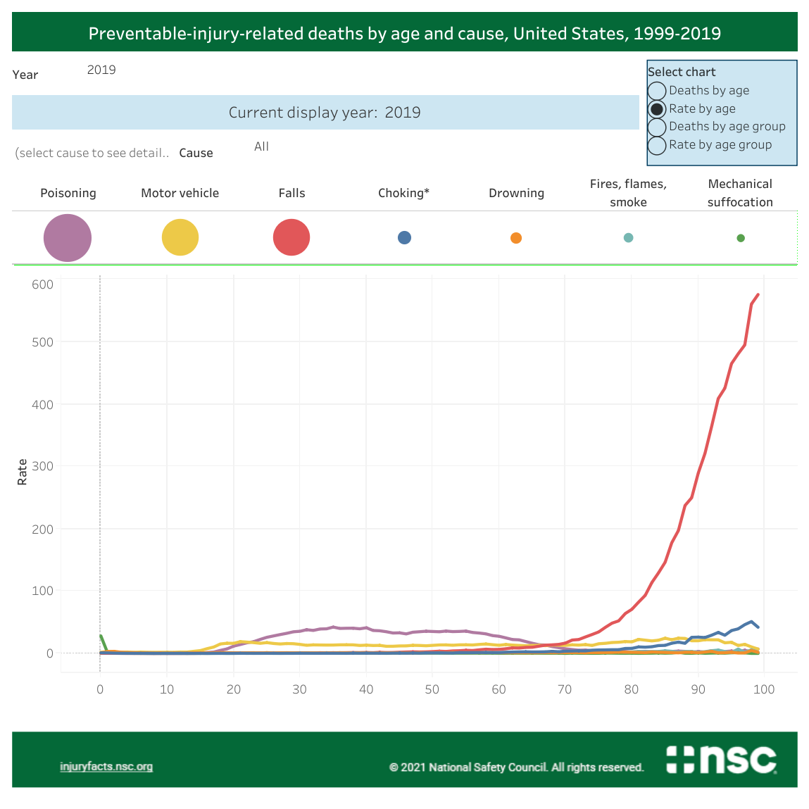
Source: https://injuryfacts.nsc.org/all-injuries/deaths-by-demographics/deaths-by-age/data-details/

