Stairs and Seniors
Stair-related injuries treated in United States emergency departments
Danielle Herbert Blazewick ¹, Thitphalak Chounthirath ², Nichole L Hodges ³, Christy L Collins ⁴, Gary A Smith ⁵
Abstract
Objective: To investigate the characteristics of stair-related injuries among individuals of all ages and estimate national injury frequencies and rates using a representative sample of patients treated in United States emergency departments.
Methods: Data from the National Electronic Injury Surveillance System were analyzed for patients treated for stair-related injuries in United States emergency departments from 1990 through 2012.
Results: An estimated 24,760,843 patients were treated in emergency departments for a stair-related injury during the 23-year study period, averaging 1,076,558 patients annually, or 37.8 injuries per 10,000 United States residents. The annual rate of stair-related injuries decreased by 12.6% (p<0.001) during 1990-1996, followed by an increase of 24.0% (p<0.001) during 1996-2012. Although the highest injury rates occurred among younger children and older adults, the majority (67.2%) of emergency department visits for stair-related injuries was by individuals 11-60years old. Most patients were female (62.4%), who also had a higher injury rate (46.5 vs. 29.1 per 10,000) than males. Sprains and strains (32.3%), soft tissue injuries (23.8%), and fractures (19.3%) were the most common types of injury. The body regions most frequently injured were the lower extremities (42.1%) and head/neck (21.6%). Patients ≤10years old experienced more head/neck injuries. Older adult patients more frequently sustained fractures than younger age groups.
Conclusions: Stairs are a common source of injury among individuals of all ages and the frequency and rate of stair-related injuries are increasing. This underscores the need for increased prevention efforts, particularly those related to stair design and construction.
Keywords: Emergency department; Injury; National Electronic Injury Surveillance System; Stairs; Stairways.
Copyright © 2017 Elsevier Inc. All rights reserved.

A need to improve the assessment of environmental hazards for falls on stairs and in bathrooms: results of a scoping review
BMC Geriatrics volume 18, Article number: 272 (2018)
Abstract
Background
Falls occurring on stairs or in bathrooms are associated with a high risk of injuries among older adults. Home environmental assessments are frequently used to guide fall-prevention interventions. The aims of this review were to describe how, where, by whom, and for whom environmental hazard checklists are used, and to examine the characteristics of environmental hazard assessment checklists with specific attention to features of bathrooms and stairs/steps assessed in them.
Methods
Studies published before January 5, 2018, were identified using several databases. Publications reporting the use and/or evaluation of environmental hazard checklists were eligible if they assessed bathrooms or stairs/steps in homes of older adults (≥65 years). Content analysis was conducted on publications that provided a complete list of specific environmental hazards assessed. Checklist items related to bathrooms and stairs/steps were extracted and categorized as structural or non-structural and as objective or subjective.
Results
1119 studies were appraised. A pool of 136 published articles and 4 checklists from the grey literature were included in this scoping review. Content analysis was conducted on 42 unique checklists. There was no widely used checklist and no obvious consensus definition of either environmental hazards overall or of single hazards listed in checklists. Checklists varied greatly with respect to what rooms were assessed, whether or not outdoor stair/steps hazards were assessed, and how responses were coded. Few checklists examined person-environment fit. The majority of checklists were not oriented towards structural hazards in bathrooms. Although the majority of checklists assessing stair/steps hazards evaluated structural hazards, most features assessed were not related to the construction geometry of stairs/steps. Objective features of bathrooms and stairs/steps that would deem them safe were rarely specified. Rather, adequacy of their characteristics was mostly subjectively determined by the evaluator with little or no guidance or training.
Conclusion
The lack of standard definitions and objective criteria for assessing environmental hazards for falls is limiting meaningful cross-study comparisons and slowing advances in this field. To inform population health interventions aimed at preventing falls, such as building code regulations or municipal housing by-laws, it is essential to include objectively-assessed structural hazards in environmental checklists.
Background
Falls among older adults are considered a major public health concern [1]. Falls can lead to loss of autonomy, greater isolation and depression, reduced mobility, and increased morbidity and mortality [2]. In Canada, the direct and indirect costs of falls among older adults are estimated at over $3 billion annually [3]. Aging-in-place policies highlight the importance of mitigating fall risks in the home [4]; safer homes may enable independent rather than dependent living arrangements for older persons.
Although causes of falls are considered multi-factorial, it is well-established that environmental hazards are implicated in as many as one third of all falls among older adults [5,6,7,8,9]. Research on falls indicates that two areas in the home are particularly hazardous for injurious falls; bathrooms, and indoor or outdoor stairs or steps [10,11,12]. In the most recently available National Electronic Injury Surveillance data for 2017, for example, the product category stairs, ramps, landings and floors is the top-ranked location of injuries in the United States for those 65 years and older, while bathtub and shower structures rank fourth for this age group [13]. Furthermore, when time spent on stairs or in bathrooms (risk exposure time) is taken into account, these locations account for a significantly higher incidence of falls than other room locations (Jake Pauls, personal communications, June 12, 2018). Stairs and bathrooms are problematic because they involve navigating transitions and transfers, and structural features of these locations (such as poor stair geometry or the lack of transfer assists) may challenge an individual’s capacity to respond to the pressure exerted by these environmental features, thereby exceeding optimal person-environment fit parameters [14,15,16,17,18,19,20,21,22,23].
Both primary studies and systematic reviews have documented the effectiveness of efforts to address environmental hazards generally, or more specifically in bathrooms and stairs [4, 6, 24,25,26,27,28,29,30]. Still, studies that assessed the influence of home environmental hazards, or of removing such hazards, on the occurrence of falls have frequently shown no significant associations [5, 31,32,33,34,35,36,37,38,39] or conflicting results [7] even if this relationship makes intuitive sense. It is our contention that these discrepant findings are influenced by how and which hazards are assessed or removed. Indeed, systematic reviews of fall prevention initiatives show that a variety of checklists have been used to assess environmental hazards and that information about their strengths and weaknesses is sparse [4, 6, 40]. Therefore, a review of what environmental hazard checklists have been developed and used is needed to more effectively prevent falls and to assess the potential for data on environmental hazards to inform policies such as building code legislation and regulated universal design.
The purpose of this scoping review was three-fold: a) to summarize how environmental hazards are defined by those developing or using environmental hazard checklists; b) to describe how, where, by whom, and for whom environmental hazard checklists are used; and, c) to examine the characteristics of environmental hazard checklists, with specific attention to features of bathrooms, and stairs/steps assessed in same. This review complements those that have focused on the relationships between falls and environmental hazards [4, 6, 40, 41] and provides a detailed examination of the assessment criteria used for two important locations in homes for injurious falls involving environmental hazards, namely bathrooms and stairs/steps.
Methods
This scoping review was conducted in a systemic manner according to the steps outlined by Arksey and O’Malley [42], and Levac et al. [43]. Reporting follows the PRISMA (Preferred Reporting Items for Systematic Reviews and Meta-Analyses) statement guidelines, as appropriate. Ethics approval was not required.
Identification of relevant articles
Papers were identified using various databases, namely: Medline, Embase, Web of Science, Scopus, CINAHL, AgeLine, HAPI, and PsychTESTS. No restrictions were set regarding the publication year. The search covered articles published up to January 5, 2018. A combination of descriptors (e.g. MESH terms) and key words was used. The authors reviewed the search syntax and strategy and provided additional search terms. The search strategy was finalized after consultation with a professional librarian and tailored for each database (Additional file 1). As an example, the following strategy was used for the search in Medline:
- (Fall OR accident OR accidental fall)
- AND (home adj3 hazard* OR environment* adj3 hazard*)
- AND (housing OR public housing OR Housing for the elderly OR home OR dwelling)
Backward searching from reference lists of reviewed articles was also done.
Inclusion and exclusion criteria
We applied inclusion and exclusion criteria in two stages. The first stage yielded a more complete set of articles, all with at least some information about environmental hazard checklists. For the first stage, the inclusion criteria were:
- Assess environmental hazards for falls in one or more of the following settings: personal homes or apartments, public housing, and housing for older persons including retirement residences, even if the checklist was not entirely described.
- Include an assessment of environmental hazards in bathrooms and/or on stairs/steps by lay and/or professional raters (e.g. nurses providing home healthcare services).
- Involve a population aged 65 years of age or older.
- Primary research study or research protocols for primary studies.
Exclusion criteria used for this first stage were:
- Focus exclusively on hospital or long-term care settings.
- Focus exclusively on a population aged less than 65 years of age (e.g. children).
- Not written in English or French.
- Conference and poster abstracts; letters, commentaries, editorials, reviews (e.g. narrative reviews, systematic reviews, meta-analysis studies), and practice guideline papers.
The second stage identified a subset of publications included in stage one that either included the checklists or provided a list of all specific environmental hazards assessed.
Study selection
Figure 1 summarizes the two-stage process used to identify and select papers included in this review. The initial database searches yielded a total of 1114 articles. The search in HAPI and PsychTESTS yielded five additional articles, for a total of 1119 articles. All articles were entered in Zotero. Duplicates were removed, leaving 470 articles. First stage inclusion and exclusion criteria were pilot-tested and refined on a subset of 10 random titles and abstracts by the two authors. Titles and abstracts were then reviewed for stage one eligibility by two independent raters (first author and a research associate) and classified as eligible (n = 36), ineligible (n = 284) or unclear (n = 150). Any discrepancies in eligibility were discussed until a consensus was reached. Articles classified as eligible or unclear underwent full-text review by the first author. After full-text review, 105 articles were deemed eligible. An additional 35 eligible articles or checklists were identified through the hand search of reference lists.

Fig. 1
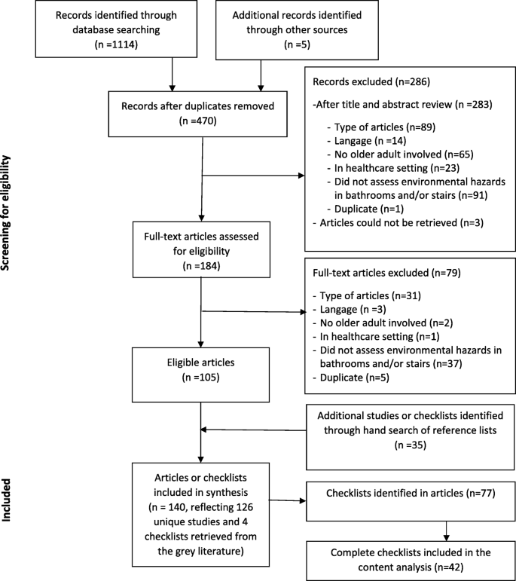
Screening process. Screening process for the scoping review on the assessment of environmental hazards for falls on stairs and in bathrooms

Stage 1
We grouped studies or checklists into four main categories based on their objectives: 1- developed a checklist and/or tested its validity or reliability; 2- used a checklist to assess environmental hazards or the impact of environmental hazards on falls; 3- used a checklist in an intervention study and/or reported home modifications; 4- not applicable, checklist only. We dichotomized checklists according to reports of psychometric testing (those with versus those without reports of validity and/or reliability testing in current or previous studies) and assessor training (authors did or did not report training of assessors). Checklists were categorized according to whether they assessed solely fall-related hazards or whether they included non-fall-related environmental hazards. The former items were defined as “aspects of the physical environment, including objects, space and the elements in and about the house that pose a risk or danger of causing the person to fall” [56] (p. 171). Items considered unrelated to falls included fire hazards, medication misuse, and wandering.
Descriptive analyses were conducted in IBM SPSS Statistics for Windows (version 24.0, Armonk, NY). We examined whether or not reports of training assessors were associated with reports of developing checklist or testing its validity or reliability (yes/no) using a Pearson chi-square test. We tested the association between time (by 1-year and 5-year period) and the proportion of studies using checklists with prior psychometric testing using Spearman correlations. P values < 0.05 were considered significant.
Stage 2
Detailed information was extracted about how hazards were evaluated in bathrooms and on stairs/steps (indoor and/or outdoor), and if and how person-environment fit was assessed. This data was then content analyzed [43, 153] using two sets of categorical descriptors. First, we rated hazards as structural or non-structural. We defined structural hazards as environmental features that were anchored in walls or on floors (e.g., grab bars affixed to wall, handrails on stairs) or were features of building construction (e.g. stair geometry). We defined non-structural hazards as environmental features that were not anchored in walls or on floors (e.g., presence of bathmats, cluttered stairs). Second, we rated assessment criteria as objective or subjective. We defined objective criteria as defined physical properties not involving personal judgment (e.g. presence of handrail, tread length, lumens of light on stairs). We defined subjective criteria as undefined descriptors requiring the individual judgement of the assessor (e.g., steep or narrow stairs/steps, sturdy handrails or grab bars, slippery surface). Using these definitions, all items for the three locations of hazards (bathrooms, indoor stairs/steps and outdoor stairs/steps) were independently rated by the authors using the two sets of categories for increased internal reliability. Any discrepancies in ratings were discussed until a consensus was reached.
Results
Stage 1
Definitions of environmental hazards
Only 22 studies (17%) provided a definition for the term environmental hazards, and there was considerable variation in these definitions across studies. Most authors who defined hazards, described them by giving examples such as, “features of the home environment such as loose rugs, floor clutter, and poor lighting” [19] (p. 2) or “environmental features such as poor lighting, lack of handrails on staircases, objects in pathways, and slippery rugs” [25] (p. 16). The most comprehensive definition provided was “home fall hazards are aspects of the physical environment, including objects, space and the elements in and about the house that pose a risk or danger of causing the person to fall and, therefore, risk injury” [56] (p. 171).

Fig. 2
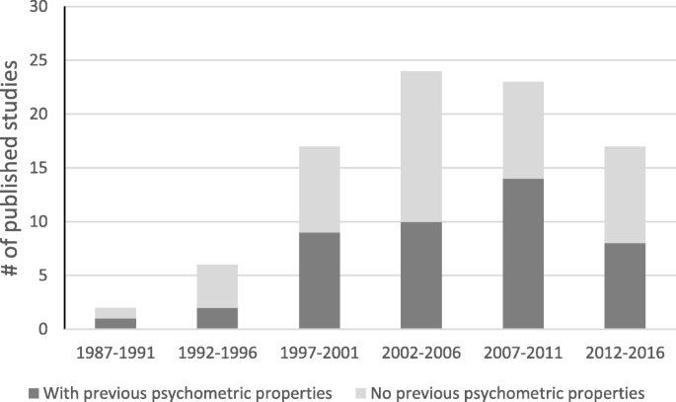
Number of articles published according to whether the checklist used had prior psychometric testing (n = 96)
Study populations
About half of the studies (n = 73, 57%) drew their sample from the general population. The remainder targeted populations at a higher risk of falls such as individuals who had fallen in the previous year; frail individuals; or individuals with mental or visual impairments.
Almost no studies adapted the type of specific home hazards assessed to the specific needs of participants. There were two exceptions. The HEAVI was developed for visually impaired individuals and focusses on related environmental features such as lighting and visual cues [19]. The HEAP was developed for individuals with dementia and includes an assessment of pressure gates at the top and bottom of stairways [15, 78].

Discussion
This is the first scoping review to examine the characteristics of environmental hazards checklists. Given the pervasive presence of environmental hazards in homes and their causal relationship with falls and independent functional mobility among the older adults, examining the status and quality of such checklists is imperative.
Despite over three decades of research in this field, there are still no widely used environmental assessment checklists. There is a lot of variability among checklists in terms of the number of items, which parts of the home were assessed, and among those assessing bathrooms and stairs/steps whether checklists emphasized structural or non-structural features or used primarily objective or subjective criteria for assessments. The lack of standardized assessment items in checklists severely limits cross-study comparisons [58]. In 2003, Gitlin concluded that there was a “lack of psychometrically sound measures” to assess home environments and that most assessment methods used were study-specific with unknown reliability and validity [155]. Our review indicates that this conclusion still largely holds. Developing “gold standard” environmental hazards checklists with known psychometric properties is critical to advance the field and inform fall-related prevention practices. This requires the development of a consensus definition of environmental hazards [58], and the identification of priority structural and non-structural attributes of safe bathrooms and safe stairs/steps. There is substantial data available from ergonomic studies to support this prioritization. Furthermore, statistical modeling of the relationship between checklist items and falls would help establish the predictive validity of checklist items, determine if it is clinically appropriate to sum all items into an overall hazard score, and identify priority objective measures for inclusion in abbreviated checklists.
We found limited descriptions of training approaches used and a lack of information on whether or not assessors were trained to use checklists. We recognize that training is costly, but agree with authors who have suggested that training is essential to achieve consistent assessments among raters [57]. For instance, interviewers have been shown to incorrectly identify towel racks as grab bars [8], highlighting the need to train them and to provide definitions of hazards. We also think that scaling-up the use of robust environmental hazard assessment checklists is important; their reach could be extended by training lay people to conduct assessments, and reducing the number of items on hazard checklists.
Given the disproportionately high rate of injurious falls that occur on stairs/steps and in bathrooms [10,11,12], it was surprising to us that checklists did not always include an assessment of these locations and that outdoor stairs/steps were so infrequently included. Outdoor stairs/steps often comprise part of older adults’ walking paths (Edwards & Dulai, under review); affect the visitability of a home; and may be more prone to hazardous characteristics since they may not be covered by building code legislation. In our view, comprehensive environmental hazard checklists need to assess both indoor and outdoor home environments.
Most of the authors describing environmental hazard checklists seemed to conceptualize the environment as an independent static entity, ignoring how older adults interact with their environment or the degree of their exposure [155, 156]. Ideally, checklists that assess person-environment fit and/or dynamic variability of the environment would be used alongside standard checklists, providing more insights on how older adults navigate their home environment in ways that either reduce or increase their risk of falls [157]. For example, checklists should assess whether older adults use stair handrails to compensate for poor balance or use a toilet or bathtub grab bar to aid transfers. Checklists should also contain items and directions pertaining to assessing the dynamic and variable nature of some environmental hazards (e.g. outdoor stairs/steps that were dry versus covered in ice or snow, friction coefficient of wet versus dry bathroom floor, combinations of natural and artificial lighting on stairs/steps that changed at different times of the day) [56].
There has been a tendency to define the problem of environmental risk modification as an individual behaviour change problem rather than as an environmental issue that requires a multi-level and inter-sectoral approach such as building code legislation and regulated universal design [158]. This behavioural emphasis may in part, explain the emphasis on subjective and non-structural items that was evident in checklists that assessed bathrooms and stairs/steps. In the longer-term, policy interventions, are likely to be more effective than behavioural interventions in facilitating some environmental modifications, such as safer stair geometry and universal access to grab bars for toilets, showers and bathtubs [159, 160]. It is imperative that we identify those constellations of hazards that are priorities and best tackled through policy change. This requires cumulative knowledge about the prevalence of structural environmental hazards and their relationship to falls. The inclusion of consistent, objectively-assessed, structural items in environmental hazard checklists could help address this knowledge gap.
Limitations
This review has several limitations. First, we focussed on hazards related to bathrooms and stairs/steps. This may have resulted in the exclusion of a few checklists assessing solely other parts of homes. Second, we did not attempt to access unpublished training manuals for checklists, which may include descriptions of items that would have led us to categorize them as objective rather than subjective. However, most studies did not mention training their assessors or having a training manual, so it seems unlikely that this would have substantially shifted our results. Third, it was sometimes hard to categorize items as structural or non-structural, or as objective or subjective due to the limited descriptors of hazards contained in many checklists. For instance, “dim lightning” could be caused by a lack of proper ceiling light fixtures (structural) or by a burned-out light bulb (non-structural). To improve reliability, both authors independently rated the environmental hazard items on checklists and discussed discrepant results until a consensus emerged. However, it might have been more rigorous to involve an independent rater in this process. Lastly, we did not judge the appropriateness of objective criteria used to evaluate hazards. We did observe that objective criteria were inconsistent across checklists. In the future, an assessment of objective criteria should include a quality assessment against standards such as those suggested in ergonomic studies or those used in existing building code legislation.
Conclusion
The lack of standard definitions and consistent objective criteria for assessing environmental hazards for falls is limiting meaningful cross-study comparisons and slowing advances in this field. This gap may partly explain conflicting results regarding the effectiveness of interventions targeting home environmental hazards (in particular those involving bathrooms and stairs/steps) to prevent falls among older adults. This field of research would be improved with standardized environmental hazard checklists containing objective criteria to assess structural hazards. To inform population health interventions aimed at preventing falls, such as building code regulations or municipal housing by-laws, it is essential to include objectively-assessed, structural hazards in environmental checklists.
SOURCE: https://bmcgeriatr.biomedcentral.com/articles/10.1186/s12877-018-0958-1

Effects of stair-climbing on balance, gait, strength, resting heart rate, and submaximal endurance in healthy seniors
First published: 27 August 2013
Abstract
Stair-climbing serves as a feasible opportunity to remain physically active within everyday-life. Data on neuromuscular and cardiorespiratory performance after regular stair-climbing in seniors are scarce. Forty-eight seniors were stratified to a one- (taking every step, INT₁) or two-step strategy (every second step, INT₂) or a control group (CON). Thirty-nine seniors [females: n = 22, males: n = 17; age: 70.5 (SD 5.1) years; BMI: 25.8 (3.1) kg/m²] completed the 8-week intervention (three weekly sessions). Before and after the intervention, balance, gait, strength, and submaximal endurance (at different intensities) were assessed. Maximal strength and explosive power did not improve significantly (0.10 < P < 0.78). Resting heart rate was significantly reduced in INT₂ (−8/min) compared with INT₁ (0/min, P = 0.02) and CON (0/min, P = 0.03). Compared with CON, perceived exertion for all intensities (0.007 < P < 0.03) and submaximal exercise heart rate during moderate uphill walking significantly decreased (−11/min; P < 0.05) in INT₂. Step counts for forward beam balancing (4.5 cm width) increased in INT₂ (P = 0.007) compared with CON. With more pronounced effects in INT₂, stair-climbing significantly improved resting and exercise heart rates, perceived exertion, and dynamic balance performance in healthy seniors and may contribute to better overall fitness, reduced fall risk, and less perceived strain during daily life activities.
Facts About Falls
Each year, millions of older people—those 65 and older—fall. In fact, more than one out of four older people falls each year, ¹ but less than half tell their doctor. ² Falling once doubles your chances of falling again. ³
Falls Are Serious and Costly
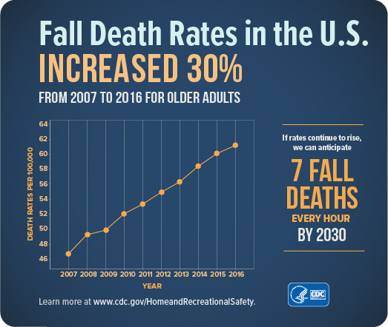
- One out of five falls causes a serious injury such as broken bones or a head injury^{,4,5}
- Each year, 3 million older people are treated in emergency departments for fall injuries.⁶
- Over 800,000 patients a year are hospitalized because of a fall injury, most often because of a head injury or hip fracture.⁶
- Each year at least 300,000 older people are hospitalized for hip fractures.⁷
- More than 95% of hip fractures are caused by falling,⁸ usually by falling sideways.⁹
- Falls are the most common cause of traumatic brain injuries (TBI).¹⁰
- In 2015, the total medical costs for falls totaled more than $50 billion.¹¹ Medicare and Medicaid shouldered 75% of these costs.
What Can Happen After a Fall?
Many falls do not cause injuries. But one out of five falls does cause a serious injury such as a broken bone or a head injury.^{4,5} These injuries can make it hard for a person to get around, do everyday activities, or live on their own.
- Falls can cause broken bones, like wrist, arm, ankle, and hip fractures.
- Falls can cause head injuries. These can be very serious, especially if the person is taking certain medicines (like blood thinners). An older person who falls and hits their head should see their doctor right away to make sure they don’t have a brain injury.
- Many people who fall, even if they’re not injured, become afraid of falling. This fear may cause a person to cut down on their everyday activities. When a person is less active, they become weaker and this increases their chances of falling.¹²
What Conditions Make You More Likely to Fall?
Research has identified many conditions that contribute to falling. These are called risk factors. Many risk factors can be changed or modified to help prevent falls. They include:
- Lower body weakness
- Vitamin D deficiency (that is, not enough vitamin D in your system)
- Difficulties with walking and balance
- Use of medicines, such as tranquilizers, sedatives, or antidepressants. Even some over-the-counter medicines can affect balance and how steady you are on your feet.
- Vision problems
- Foot pain or poor footwear
- Home hazards or dangers such as
  - broken or uneven steps, and
  - throw rugs or clutter that can be tripped over.
Most falls are caused by a combination of risk factors. The more risk factors a person has, the greater their chances of falling.
SOURCE: https://www.cdc.gov/falls/facts.html

