Shoes and Seniors
Did you know that, according to an article in Geriatric Orthopaedic Surgery & Rehabilitation, close to 80% of elderly people experience foot problems?
Common Footwear Problems in Older Adults
As people get older, their feet undergo numerous changes that can affect the fit of their shoes. For example, your skin gets thinner and you lose fat padding on the bottom of your feet, so you may need extra cushioning in your shoes in order to stay comfortable. Your joints also get stiffer, and your arches get flatter. Plus, your feet tend to spread out more as tendons and ligaments lose strength, so you may find that you need a bigger or wider shoe than you used to.
In addition, conditions like arthritis and diabetes can cause your feet or ankles to swell, so you will likely need shoes that have adjustable openings and fasteners that can accommodate your changing size. Arthritis can also make it painful to tie up laces, so Velcro shoes for seniors may be a good option.
Here are some common foot issues that seniors experience:
- Corns or callouses: Hardened patches of skin that often develop as a result of repeated friction or pressure
- Bunions: Bony bumps that develop on the joint at the base of the big toe, forcing the joint to stick outwards
- Fallen arches: A condition in which the tendon supporting the foot arch weakens and allows the entire foot to contact the ground (something that can lead to knee and back pain)
- Hammertoe: A deformity of the toe joint that causes the toe to curl downwards rather than point forward
- Plantar fasciitis: Inflammation of a band of tissue along the bottom of the foot that causes heel pain, particularly first thing in the morning
The good news is that the pain and discomfort that accompanies these problems can often be improved by choosing the appropriate footwear. The right pair of shoes can also help keep you balanced, reduce the risk of falls, prevent knee and back problems, and encourage you to stay physically active.
SOURCE: https://www.greatseniorliving.com/articles/shoes-for-seniors

Footwear and Falls in the Home Among Older Individuals in the MOBILIZE Boston Study
Background
Whether certain types of footwear, such as slippers, socks without shoes, and going barefoot, increase the risk for falls among the elderly is uncertain. Our purpose was to examine the relationship between footwear and falls within the home in MOBILIZE Boston, a prospective cohort study of falls etiology among non-institutionalized women and men, mainly aged 70 years and older, from the Boston MA, USA area.
Methods
The 765 participants were from households randomly selected from town lists. They were followed for a median of 27.5 months. At baseline, participants were administered a questionnaire that included questions on footwear usually worn, and were given a comprehensive examination that included measurement of many risk factors for falls. During follow-up participants were asked to record each day whether they had fallen; those reporting falls were asked about their footwear when they fell.
Results
At the time of in-home falls, 51.9% of people were barefoot, wearing socks without shoes, or wearing slippers; 10.1% of people reported that their usual footwear was one of these types. Among those who fell in their own home, the adjusted odds ratio for a serious injury among those who were shoeless or wearing slippers compared to those who were wearing other shoes at the time of the fall was 2.27 (95% confidence interval 1.21–4.24).
Conclusions
It may be advisable for older individuals to wear shoes in their home whenever possible to minimize the risk of falling. Further research is needed to identify optimal footwear for falls prevention.
SOURCE: https://www.ncbi.nlm.nih.gov/pmc/articles/PMC3250347/

Falling is dangerous, no matter what age you are! The effects can be severe and long-lasting, and lead to other problems.
A dangerous fall doesn’t have to be from a height, especially for an elderly person. Simply tripping and falling from normal, walking height can have disastrous effects for an older person.
If you’re looking for a way to help your elderly loved one stay safe, choosing specific shoes for elderly to prevent falls can make a huge difference.
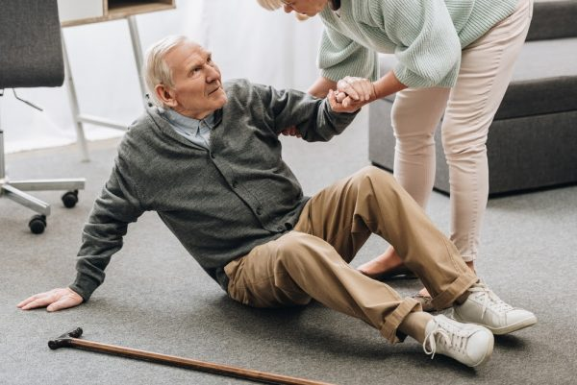
Elderly Falls Statistics
The CDC provides data on falls, and although some of their data is as old as from 2016, the statistics are still pretty scary.
Here’s some falls information you may not be aware of:
- 20% of falls cause severe injury such as fractures or head injuries.
- Almost all hip fractures are caused by falling.
- More than 25% of elderly people fall every year.
- Falling once doubles the chance of falling again!
Although these stats may be a little outdated, they’re scary enough to help us understand why falls are so dangerous and why we need to do our best to help prevent them.

We have broken them down into 3 categories:
Best Slip-Resistant Walking Shoes
Best Multi-Purpose Slip-Resistant Shoes for Indoor & Outdoor Use
Best Slip-On Shoes
SOURCE: https://seniorcarecorner.com/shoes-for-elderly-to-prevent-falls

