Fall Prevention Tips:
- EXERCISE! – There is an exercise routine for everyone, we can help you build strong legs and a strong core.
- Clean the clutter from your home – Remove rugs, clothes and furniture that is no longer used or can impede regularly used walk areas.
- What’s on your feet? – Your shoes can impact balance based on how much they support your feet.
- Light the way – Set up night lights along the way to the bathroom and kitchen so that you can see obstacles at night.
- Med check – Medications such as tranquilizers, sedatives, or antidepressants can impact your balance. Even some over-the-counter medicines can affect how steady you are on your feet. Check with your physician regarding your meds.
- Vision and/or hearing – When was the last time you’ve had your vision and/or hearing checked. Vestibular disorders, such as vertigo, can also greatly affect balance.
- Vitamin D - Studies suggest that adequate vitamin D reduces the risk of falls by increasing muscle strength in the legs. The recommended daily intake is 600 IU up to age 70 and 800 IU for those older, but we recommend 800 to 1,000 IU a day for most people (American Geriatrics Society).

3 BEST Exercises to Improve your Balance
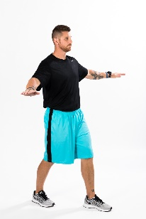
POC (Position Of Confidence)
2 x 20-30 seconds
This is the base position of BU. From the POC, we will add variable and increase proprioception.

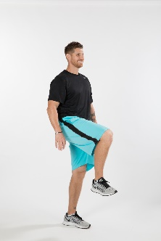
SL Hip & Knee Flexion
2 x 8-12
Be safe and hold onto a chair or table until you become familiar with the exercise. Lift leg to a 90-degree angle and return to start positon.

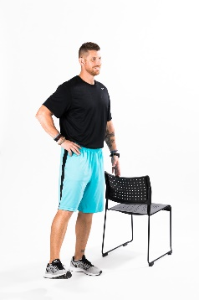
SL Laterals
2 x 8-12
Be safe and hold onto a chair or table until you become familiar with the exercise. Lift your leg to the side and then return back to start position.

