New Year’s Resolutions and Balance
Balance Training
By Stephanie Watson
How It Works
Though it might not cross your mind, you need good balance to do just about everything, including walking, getting out of a chair, and leaning over to tie your shoes. Strong muscles and being able to keep yourself steady make all the difference in those and many other things you do every day.
Balance training involves doing exercises that strengthen the muscles that help keep you upright, including your legs and core. These kinds of exercises can improve stability and help prevent falls.
Doing balance exercises can be intense, like some very challenging yoga poses. Others are as simple as standing on one leg for a few seconds. Or you can use equipment that forces your body to stabilize itself…
Examples of balance exercises include:
- Standing with your weight on one leg and raising the other leg to the side or behind you
- Putting your heel right in front of your toe, like walking a tightrope
- Standing up and sitting down from a chair without using your hands
- Walking while alternating knee lifts with each step
Intensity Level: Moderate
To balance train, you don't have to run, jump, or do any other high-impact or high-intensity exercises. Usually balance training involves slow, methodical movements.
Areas It Targets
Core: Yes. You need strong core muscles for good balance. Many stability exercises will work your abs and other core muscles.
Arms: No. Most balance exercises are about balancing on your feet. So unless you're doing moves that involve your arms, or you're holding weights, they don’t work your arms.
Legs: Yes. Exercises in which you balance on one leg and then squat or bend forward also work the leg muscles.
Glutes: Yes. The same balance exercises that work the legs also tone the glutes.
Back: Yes. Your core muscles include some of your back muscles.
Type
Flexibility: No. Balance training is more about strengthening muscles and improving stability than gaining flexibility.
Aerobic: It can be, but often is not. It depends on how intense the activity is. If you're moving fast, then it may be aerobic. Slower balance exercises do not make you breathe faster or make your heart pump harder.
Strength: Yes. Many of these exercises will work your muscles, especially the muscles of your legs and core. Some moves may also use your chest and shoulder muscles, like the plank position in yoga.
Sport: No. Balance training involves a series of exercises. It is not a sport.
Low-Impact: Yes. There is no impact involved in doing balance exercises.
What Else Should I Know?
Cost. No. You can do balance exercises on your own, with nothing more than a chair. There is a cost if you want to take a tai chi or yoga class, or buy a stability ball, video, or other piece of equipment.
Good for beginners? Yes. Balance training is good for people of any age and fitness level. It's recommended for older adults to help prevent falls.
Outdoors. Yes. You can do balance exercises anywhere: in your backyard, on a beach, in a park.
At home. Yes. You can do these exercises at home.
Equipment required? No. You only need your own body to do balance exercises: for example, by standing on one leg. Or you can buy a piece of equipment like a Bosu ball to challenge your balance even more.
What Dr. Michael Smith Says:
The beauty of balance training is that anyone can, and should, do it. Balance training improves the health, balance, and performance of everyone from beginners to advanced athletes, young and not-so-young.
If you’re new to exercise, it’s a great place to start. Focusing on your core and balance improves overall strength and gets your body ready for more advanced exercise. Start off easy. You may find that you need to hold onto a chair aft first. That’s absolutely fine.
If you’re an advanced exerciser, you’ll likely find you still need to start with somewhat simple moves if balance isn’t your thing. Then push yourself to perform more complex moves that both challenge your muscular strength and your aerobic stamina. If you think balance exercises are easy, you haven’t tried yoga's warrior III pose.
Is It Good for Me If I Have a Health Condition?
If you have back pain, balance training is one of the best ways to strengthen your core and prevent back pain. If you’re recovering from a back injury, get your doctor’s OK and then start balancing. It’ll help prevent more problems in the future.
When you strengthen muscles, it also helps arthritis by giving more support to painful joints. You may need to adjust or avoid certain moves to decrease pressure on your knees. For example, a balance move that involves a lunge may be more than your knees can handle. Good news is there are many exercises to choose from.
If you have diabetes, high blood pressure, high cholesterol, or even heart disease, exercise is a must to help you get control of your condition. Balance training is an excellent place to start. The first step of resistance training should focus on core and balance exercises, according to the American Council on Exercise. As you get stronger and become able to perform more intense exercises, balance training can give you an aerobic workout that even helps control blood sugar, cholesterol, and blood pressure along with other aerobic exercise.
If you’re pregnant, choose your balance exercises carefully. Women can and should exercise during pregnancy. The main concern with exercise during pregnancy is falling, so moves that make you unstable are not a good choice. Choose balance moves that either keep both feet on the floor or that you do on all fours, like plank (you may need to support your body with one knee on the ground). As with any exercise, if you did it before pregnancy, you’re likely OK doing it after pregnancy. It's always good to check with your doctor to be sure.
WebMD Fitness A-Z Reviewed
By: Tyler Wheeler, MD on November 23, 2020
SOURCE: https://www.webmd.com/fitness-exercise/a-z/balance-training

Every year, millions of people make New Year’s resolutions, hoping to spark positive change. The recurring themes each year include a more active approach to health and fitness, improved finances, and learning new things for personal and professional development. Chances are, more than a couple of the top 10 most common resolutions will look familiar to you:
- Exercise more
- Lose weight
- Get organized
- Learn a new skill or hobby
- Live life to the fullest
- Save more money / spend less money
- Quit smoking
- Spend more time with family and friends
- Travel more
- Read more
SOURCE: https://www.goskills.com/Soft-Skills/Resources/Top-10-new-years-resolutions
Every New Year’s Eve, millions of people around the globe celebrate with the hope that next year will be better than the last.
Well, chin up: A recent Finder survey reveals that 141.1 million adult Americans — or 55.31% of all American adults — think that following through on their New Year’s resolutions is well within the cards.
At least they made resolutions. Some 25.98% of adult Americans are rolling into 2021 without personal goals on the calendar.
How many Americans will make a New Year’s resolution?
An estimated 188.9 million adult Americans (74.02% of the population) say they’re determined to learn something new, make a lifestyle change or set a personal goal in an effort to better themselves in 2021, a 15.17% increase from the previous year. The top six categories that keep us to this holiday tradition relate to money, health, career, self-improvement, family, and love.

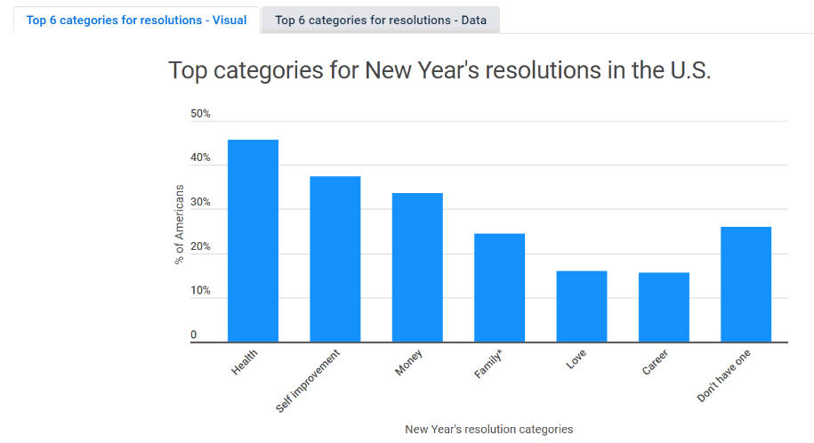
Gender
Of those surveyed, some 73.76% of men and 74.26% of women plan to make a 2021 resolution.
Health-related resolutions are at the top of the list: 43.53% of guys and 47.45% of gals. Not too shocking for a world currently in a health pandemic. Health insurance can be one of the more complex insurance types. To better guard your health and insurance research how health insurance works and compare policies and plans when making your choice.
The least targeted resolution across the board still relates to a career — which is ironic, given that money is second to health for 35.18% of men.
As for women, 40.00% lean toward self-improvement, and 32.34% plan to set a money-related goal.
By Generation
The majority of millennials — 88.60% of this generation, representing 58.7 million millennials — say they’ll make a New Year’s resolution in 2021. An even higher percentage of gen Z’ers plan to have a resolution at 91.85%. However, the number of “resoluters” falls off as ages increase. About 78.61% of gen Xers, 60.91% of baby boomers, and 46.86% of the silent gen plan to throw their hat in the resolution ring next year.
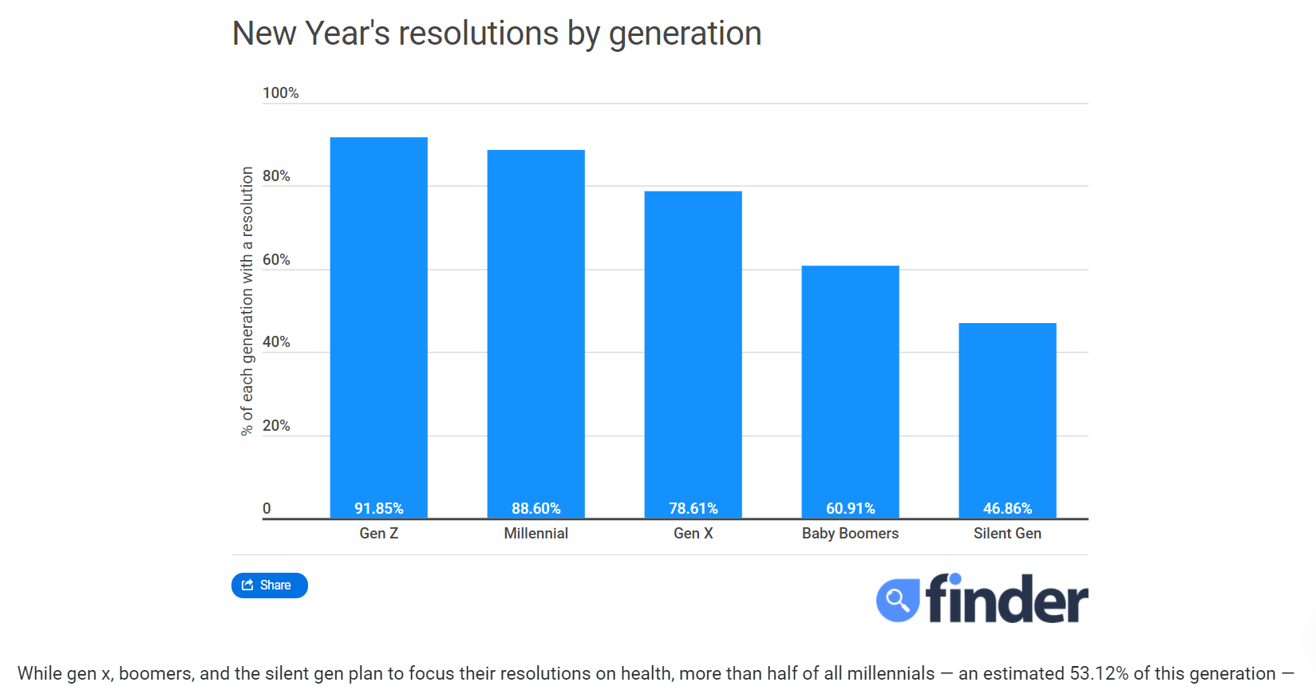
SOURCE: https://infogram.com/usfin-pr-new-years-resolution-statistics-update-2021-1hxj48p5y1q3q2v

How many Americans think they’ll fail their resolution?
If you’ve ever been to a gym in the first week of January, you’ve witnessed the great migration of “resoluters.” You’ve probably also seen that crowd thin by mid-February.
According to our survey, an estimated 23.1 million Americans — or 12.23% of all Americans with resolutions — don’t believe that meeting their resolution is within reach. Compare that to 141.4 million optimists, or 74.72% of all Americans with resolutions, who feel that next year’s resolution is in the bag. Sitting somewhere in the middle of resolution completion is nearly 24.7 million Americans, about 13.06% of adults with resolutions the population, who think it’s possible — but they aren’t entirely confident are neutral about the outcome of their resolutions.
Gender
A small slice of men and women are naysayers of resolution success next year: Just 12.61% of women and 11.80% of men head into the new year prepared expecting to fall.
Then there are those who think they’ll crush their annual intentions. The 77.51% of men who believe they’ll achieve their goal outnumber 72.21% of women who say the same.
10.69% of men and 15.19% of women are unsure whether they will succeed or fail in their resolutions next year.
Generation
None of the generations are writing resolutions off completely, but most are hesitant to say that they won’t reach their goal. Only 7.10% of gen z, 9.71% of millennials, 15.29% of gen x, 14.93% of baby boomers, and 12.20% of the silent gen say they won’t hit the mark next year.
Most people are pretty confident that they’re resolution will be achieved this year. 83.43% of Gen Z and 78.16% of Millennials believe that they’ll achieve their resolution this year. However the number of confident “resoluters” decreases as age increases. 72.48% of Gen X, 69.55% of Baby Boomers, and 69.51% of Silent Gen say they are likely to succeed this year.
